Delfs CRM

Invoicing
Purpose:
- Improve efficiencies of invoicing by reducing the number of steps required. Current process:
  - Drafts printed and issued to Project managers (PMs)
  - PMs review information in WFMax, Fee proposals folders (or emails), and previous Invoices and hand mark-up changes inclusions
  - Mark-ups/Drafts are re-entered into WFM
  - Finals issued for approval to PM, changes are made and returned
  - Invoices are issued
How:
- Times captured under relevant Tasks/Stages/Phase/folders of a project
- Times, Costs, Purchase orders, Quotes, Fee type (e.g. Fixed, Hourly), and Third party approvals (Dockets) already linked to tasks ahead of invoicing period
- Surveyor can review all information easier as it all together and reasonably automated

My Work
- Need to be able to push jobs to fieldwork easily
- Only allows one item per Task. Needs to allow multiple items as there’s always more than one thing happening with a Task at a time

Projects
- Need a tab for
  - All Projects
  - My Projects

Details

Tasks
- Need to show a historical record of times etc. E.g. Cost vs Invoices

Time
- Need to be able to move times from one task to another easily
  - Possible idea (TR), “Splitting time” where time from one task is shared over 2 more more

Invoicing
- Invoicing needs to be Streamlined. A single step then out the door would be ideal
- Hourly rate jobs
  - Format is to show all time logs
  - Need to be able to edit entries if there are unsuitable for client viewing
  - Need to be able to adjust hours
  - Need to be able to select/unselect times
    - Times that are selected will be included in the invoice
    - Time that are unselected can be:
      - Carried to next month (left in WIP), or
      - Written off (time that cannot be invoiced).
  - Need to able to add a new entry
- Fixed Fee Jobs
  - Quote number should be referenced on invoice.
  - Format is: Quoted, Previously invoiced, This Claim, Remaining.
  - Invoice should state whether it is a Progress Claim or a Final Claim.
  - Items that are selected and unselected should change the total in the “This Claim” and the “Remaining” fields.
  - Time entries and hours don’t need to be editable, as there is only a number needed (This Claim).
  - Need to be able to select/unselect times
    - Selected times are invoiced (or written off – same thing in this scenario)
    - Unselected times are carried into the following month
  - Variations to fixed fees
    - Need a way of selecting items that are variations to fixed fees (possibly a check box that)
    - Variation should be located directly beneath the fixed fee work as its own Task in the invoice. (see appendix)
    - Quote number should be referenced on invoice (e.g. Variation to fixed fee Qxxxx).

Documents
- The invoice being saved to documents is not the same as the invoice shown from the ‘Invoicing’ tab when clicking “Print Invoice”

Quotes
- Idea: Have an option to create a new invoice from existing (for example is you created a very specific quote for a client and don’t want to create it again – similar to what we do with word templates already)
- Need a search and/or filter function for finding past quotes
- When accepting a quote, the new job details new to be filled out in all fields (missing: State, Postcode, Section number, LGA, Parish and County). Currently you can search the address and auto populate but you should have to.
- When entering an existing quote, the items should be listed (e.g. locate trees, connect to AHD etc). Currently you can this this when printing a quote but you shouldn’t have to.
- Quote builder: Needs the Hourly rates included for all Roles. By default have the Registered Surveyor, Field Surveyor, Office Surveyor and Drafter checked.

Clients

Staff

Field Schedule
- If this is built, automatic flags can be raised is times have not been entered in correctly into the timesheet
  - Example: If it is known that a surveyor is going a site to do a specific survey, the invoicing system would want to send a notification if no times were recorded where expected.
  - Alternatively, if times are entered where they are NOT expected, then a notification can be sent out also.
- Staff with Roles listed as “Field Surveyor” should have “Surveyor Hours” tally shown (e.g. ‘Ben S. - 0h’) so it is obvious who has not had field work allocated to them yet.
- Change the Column headings from “Field Surveyor(s)”, “Job Manager” and “Office Surveyor” to “Field”, “Manager” and “Office” respectively to reduce the column widths to make more space.

Timesheets

Reports

Settings

Field App
- Currently this compresses the image to 20% which is only need for site photos. This should be 100%.
- Site specific SWMS
  - Need to be able to include this somehow
- Dockets
  - Signatures on-site, or
  - Email to relevant people requesting signature when not on-site

Appendix

Invoice example

Plan of Subdivision 10 Lots (Progress Claim for Q5010)

Quoted: | $12,000.00
Invoiced: | $4,000.00
This Claim: | $6,000.00
Remaining: | $2,000.00

(Option A)
Plan of Subdivision 10 Lots (Variation to Fixed fee Q5010)
12/03/2026 | Field Surveyor | Set out extents of work | 8:00 | 190.00 | 1,520.00
13/03/2026 | Registered Surveyor | Consulting Stage 2 Subdivision Plan | 4:00 | 220.00 | 880.00
15/03/2026 | Field Surveyor | Lot Pegging | 8:00 | 190.00 | 1,520.00
15/03/2026 | Registered Surveyor | Compiling data and Briefing Surveyor | 1:00 | 220.00 | 220.00
18/03/2026 | Field Surveyor | Lot Pegging | 4:00 | 190.00 | 760.00
19/03/2026 | Registered Surveyor | Data reductions and issue sketch | 2:00 | 220.00 | 220.00
(Option B)
Plan of Subdivision 10 Lots (Variation to Fixed fee Q5010)
Registered Surveyor |  |  | 7:00 | 220.00 | 1,540.00
13/03/2026 | Consulting Stage 2 Subdivision Plan | 4:00
15/03/2026 | Compiling data and Briefing Surveyor | 1:00
19/03/2026 | Data reductions and issue sketch | 2:00
Field Surveyor |  |  | 20:00 | 190.00 | 3,800.00
12/03/2026 | Set out extents of work | 8:00
15/03/2026 | Lot Pegging | 8:00
18/03/2026 | Lot Pegging | 4:00

ABTrack
- Tasks & Invoicing
  - Purchase orders

- Timesheets, Jobs setting, Invoicing
  - Third Party sign-offs (Approvals)

- Clients & Invoicing
  - C/- (Care off) Working on behalf of / Invoice another

- Jobs
  - Job Diary (File notes relating to the job)
  - Projected timeline of projects
    - Notifications
    - Alerts before the set date

- Quotes
  - Allows for quotes to still be issued via word/pdf
    - Save pdf to quotes (not keen on this, but could be required)

Bec
- Staff names should not be on invoices (Done)
- For invoices, need to have the option of
  - showing individual lines and
  - not showing individual lines (can round on this option) THIS IS 80% OF JOBS
- Need to build in exceptions to typical Roles
  - E.g. Liam works in the field, or as a Drone Pilot that day
- Invoices are to be sent directly to Xero after pressing “Mark as Sent” (or similar)

- Xero needs to talk with DLCS CRM and automatically mark as paid. No need for this button (still need the others though)
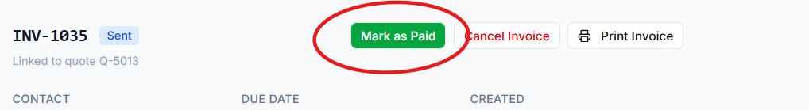
- Unpaid invoices: Consider a FLAG that notifies the PM that more work should not be done for that client until payment is made

- These need to update when issuing invoices etc. 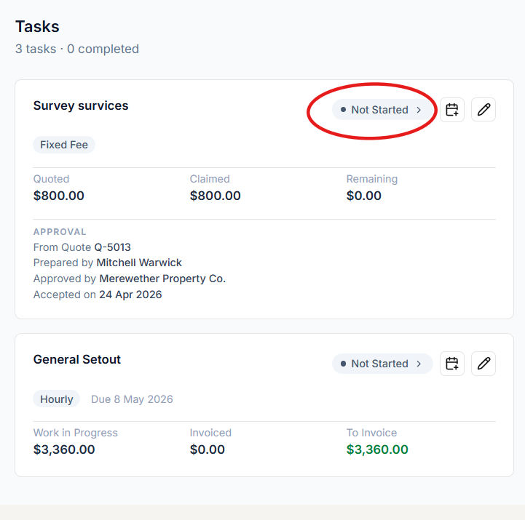

AB
Before sending invoices, get
Authenticate invoices.

